Project Progress Report for
Smart Event Management

and Ticketing System

Practice Module for Certificate in Designing Modern Software Systems

Team 10
Members:
Lu Junyi
Hu Jia
Chai Muyang
Huang Haoyang
Luo Runzhou

Sprint 2
Prepared 25 September 2026
Submission 26 September 2026

CONTENTS
1. Introduction 3
1.1 Project Name and Description 3
1.2 Project methodology 3
1.3 Project Summary 3
2. Project Progress Report 4
2.1 Reporting period 4
2.2 Sprint 2 4
2.3 Sprint objectives 4
2.4 Sprint accomplishment 4
2.5 Sprint burndown chart 5
2.6 Problems encountered and action plan 6
2.7 Sprint retrospective 6
3. Project Team Members Contribution Summary 7
4. Other Highlights and Supporting Evidence 8
4.1 Plan for the next two weeks 8
4.2 Product backlog and definition of done 9
4.3 Sprint acceptance criteria 10
4.4 User Interface 11
4.5 Test evidence 13
4.6 Continuous integration evidence 14

Introduction

Project Name and Description
Smart Event Management and Ticketing System (SEMS) centralizes event creation, ticket availability, bookings, payment-status tracking, attendance, notifications and reporting. It serves attendees, organizers, event staff and system administrators. Real payment gateways, native mobile applications and advanced recommendation features remain outside the proposal scope.

Project methodology
The project follows the proposal’s incremental iterations using Scrum practices. Sprint 2 extends the Sprint 1 registration, authentication and role-management foundation with event management and public browsing. The companion workbook organizes 24 tasks across ten relative working days, with 92 planned task hours and an 8-hour defect and integration buffer.
The Sprint 2 commitment is narrower than the indicative plan in the Sprint 1 report: ticket types and booking work are deferred to a later sprint. This report follows the current Sprint 2 workbook. Task status, acceptance results and process closure are assessed separately because the workbook’s evidence checklist has not been reconciled with the delivered files.

Project Summary
The supplied evidence demonstrates a working event lifecycle: an organizer creates and edits a private draft, publishes it for public discovery, and cancels it while retaining the management record. Role checks and ownership isolation restrict management access. The Docker and Chrome acceptance run on 24 September passed 16 grouped checks across preparation and verification, including persistence after all three containers restarted.
The workbook marks 19 tasks complete and five in progress. The unfinished tasks concern use cases, analysis/design models, Sprint Review and burndown records, retrospective actions, and actual effort attribution. The supplied CI history shows successful PR and main-branch runs through PR #17 and merge commit 3cf9fdd. Backend and frontend screenshots show 42 and 37 passing tests. Independent peer approval and formal meeting records are not established by these screenshots.
Evidence basis: W1 — SEMS_Sprint2.xlsx; E1 — 24 September acceptance README and prepare/verify JSON; E2 — container and migration records; E3 — supplied acceptance screenshots; R1 — repository Sprint 2 readiness/progress notes; R2 — inspected CI workflow. E4 — supplied backend/frontend test screenshots; E5 — supplied CI history for runs #20–30. Test results are supplied execution evidence, not new runs performed during report preparation.

Project Progress Report

Reporting period
Reporting period: 14–25 September 2026, covering ten working days. Sprint 2 starts on 14 September; this report is prepared on 25 September for submission on 26 September 2026. The evidence includes the 24 September browser acceptance and the backend test execution completed on 25 September.

Sprint 2
The sprint delivers organizer event management and public access to published events. Ticket inventory, bookings, payments, refunds, QR codes, check-in, notifications and reporting are outside this sprint. Capacity records the event size only.

Sprint objectives
Deliver draft creation and editing, controlled publication and cancellation, title search and public details; enforce role and owner access; retain the Sprint 1 authentication flow; and verify the integrated application with PostgreSQL and Docker.

Sprint accomplishment
Work planned | Evidence at reporting cutoff | Status
Event lifecycle | Create/edit draft, publish, cancel; published and cancelled records cannot be edited. E1, E3. | Acceptance evidenced
Public browsing | Published-only search and details; cancelled event disappears from search and public details return 404. | Acceptance evidenced
Access control | Guest management 401; attendee/staff 403; other organizer and admin accessing another owner’s event 404. | Acceptance evidenced
Frontend and dashboards | Organizer summary, role-specific entry points and 390px detail/management checks. | Acceptance evidenced
Database and deployment | Three Flyway migrations successful; edited draft survives service restart. E2. | Runtime evidenced
Tests and integration | 42 backend and 37 frontend tests passed in supplied screenshots; CI #20–30 successful; 16 acceptance groups passed. | See section 4.5
Process and documentation | Five tasks remain in progress; evidence checklist and actual hours need updating. | Closure incomplete

Sprint burndown chart
The 100-hour baseline comprises 92 planned task hours and an 8-hour integration buffer. The solid line reconstructs remaining effort for reporting, using the work sequence and dated delivery evidence. The dashed line is the ideal plan. Daily values are estimates, not recorded timesheets.
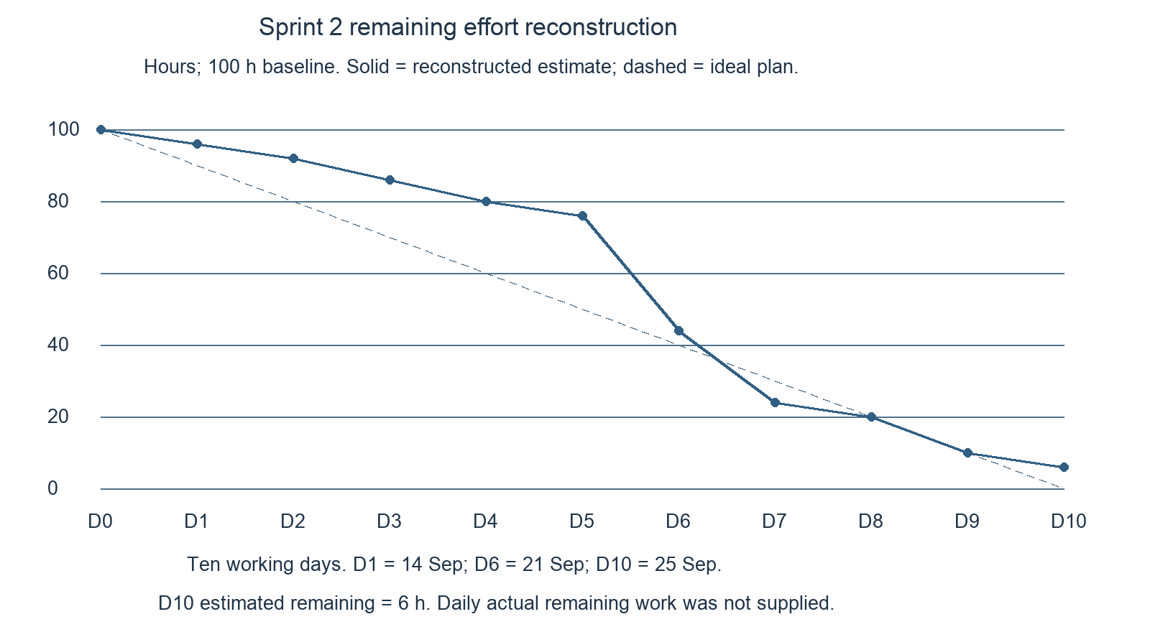
Figure 1. Sprint 2 estimated remaining effort, reconstructed for the reporting period.
Baseline | Estimated effort used | Estimated remaining
100 h | 94 h | 6 h
The profile assigns early effort to preparation, followed by the event implementation and PR milestones on 21 September, dashboard/regression work on 22 September, Docker acceptance and the Nginx fix on 24 September, and testing/report consolidation on 25 September. Intermediate values are reconstruction inputs rather than observed completion dates.
The residual 6 hours reserve the original 3-hour estimates for S2-03 use cases and S2-04 analysis/design models. The reconstruction allocates 8 buffer hours to integration and fixes and includes report/closure preparation within the 94 hours. It does not establish that Review or Retro meetings occurred. The workbook’s original task-status snapshot remains unchanged.

Problems encountered and action plan
Issue | Action and proposed owner | Status or target
Docker login returned 403 on a non-default port | Nginx now forwards the original Host including port. Rebuild and lifecycle acceptance succeeded. Lu Junyi / Huang Haoyang to retain the accepted revision. | Resolved; PR #17 merged; CI #29 and #30 successful
Evidence checklist conflicts with completed task rows | Link existing screenshots, logs and checks to tasks; update checklist only after review. Huang Haoyang / Lu Junyi. | Before Sprint closure
Daily effort was not logged in the supplied workbook | Use the labelled reconstruction in this report; capture actual daily records next sprint. Lu Junyi / all members. | Estimates consolidated for reporting
Use cases and analysis/design models remain in progress | Record their actual status and carry over unfinished items. Chai Muyang / Luo Runzhou. | S2-03 and S2-04 in progress
Peer approval and security-scan evidence incomplete | Retain successful CI #30 and attach another member’s approval if available; record the scan gap. Lu Junyi / Huang Haoyang. | Required evidence not supplied
Role changes require a new login | Retain the documented JWT behavior and explain re-login after role assignment. Hu Jia / Chai Muyang. | Observed in acceptance

Sprint retrospective
Evidence-based reflection: the integrated acceptance exercise exposed a deployment-specific login failure that component tests had not demonstrated. Rebuilding the frontend and repeating the business flow provided a useful check of the fix. Owner isolation was also tested through direct requests, alongside the visible UI behavior.
The next cycle should capture acceptance results, PR approval and daily remaining work as tasks finish, and run the Docker flow before the final review. S2-23 is still in progress. These are proposed retrospective actions, not minutes of a completed meeting; participants, feedback and agreed owners remain to be confirmed.

Project Team Members Contribution Summary
Contributions follow the detailed task assignments and supplied delivery evidence. The reporting estimate totals 94 hours, with Lu Junyi contributing the largest share. Estimated effort is a retrospective allocation for this report, not a claim that individual timesheets were supplied.
Member | Contribution summary | Plan h | Est. h
Lu Junyi | Backlog and interface coordination; event creation and state transitions; integration, CI and Nginx fix; acceptance and report consolidation. | 29 | 34
Hu Jia | Frontend routes and organizer forms; authentication integration, lifecycle confirmation and documentation. | 14 | 15
Chai Muyang | Owner management, public event queries and authorization; contribution to use-case work, with documentation still open. | 17 | 15
Huang Haoyang | Sprint 1 baseline checks, public browsing interface and Docker/browser integration support. | 13 | 14
Luo Runzhou | Database schema and migrations; backend/frontend test consolidation and regression; analysis/design documentation still open. | 19 | 16
Task total | Original task plan compared with reconstructed effort used. | 92 | 94
Buffer | Original 8-hour allowance allocated to integration and fixes in the reconstruction. | 8 | Included
Overall | 100-hour budget; estimated 6 hours remain. | 100 | 94
The allocation reconciles as follows: the 92-hour task baseline less 6 hours reserved for open documentation gives 86 hours, plus 8 hours allocated to integration and fixes gives 94 hours. Buffer effort is allocated as 5 hours to Lu Junyi and 1 hour each to Hu Jia, Chai Muyang and Huang Haoyang. The remaining 6 hours are associated with Chai Muyang’s use-case work and Luo Runzhou’s model work.
The CI screenshot shows commits and PR activity under seventh720, supporting Lu Junyi’s integration role. Other member allocations follow the team task plan and are reporting estimates; the screenshot does not independently establish every member’s authorship.

Other Highlights and Supporting Evidence

Plan for the next two weeks
Proposed window: 28 September–9 October 2026, subject to team scheduling. Close the remaining Sprint 2 evidence first, then confirm the scope and capacity for ticket types and booking work. The actions below are planning inputs, not an approved commitment or completed design.
Planned action | Proposed owner | Expected outcome
Close Sprint 2 records and reconcile the workbook | Lu Junyi / all | Review/Retro decisions, confirmation of estimated contributions and carry-over list.
Verify the final accepted revision | Lu Junyi / Huang Haoyang | Archive successful CI #30 and Docker/browser evidence; confirm independent approval.
Resolve outstanding Sprint 2 documentation | Chai Muyang / Luo Runzhou | Confirm which existing use-case/model items are complete and assign any remaining work.
Prioritize ticket types and booking stories | All members | Agreed backlog and acceptance criteria, including capacity and event-state dependencies.
Implement the agreed ticketing slice | Owners to be confirmed | Ticket type, quantity and pricing behavior for the selected stories, with tests.
Implement the agreed booking slice | Owners to be confirmed | Booking and eligible cancellation behavior with inventory consistency tests.
Maintain regression and release evidence | Hu Jia / Luo Runzhou | Identity and event lifecycle remain working after the next increment.
No new effort total is assigned until the team confirms availability and carry-over work. Payment, check-in, notifications and reporting retain their later-backlog status unless the next planning meeting explicitly changes scope.

Product backlog and definition of done
Story | Sprint 2 scope | Current evidence
US-201 | Create an event draft | 201 response; private draft; supplied preparation results.
US-202 | List, read and edit own drafts | Edited draft retained after restart; owner isolation checked.
US-203 | Publish an event | UI confirmation and public visibility; repeated publish rejected.
US-204 | Cancel an event | Confirmation, CANCELLED management record, public removal and irreversible state.
US-205 | Browse and search published events | Title search, public details and preserved search state; 390px layout checked.
US-206 | Verify authorization and authentication regression | Role assignment/re-login, 401/403 boundaries and cross-owner 404 checks.
These Sprint 2 story IDs refine the event-management and public-browsing work previously described as US04 and US06. The earlier US05 ticketing and US07–US08 booking items remain deferred. US09–US12 cover later payment-status, check-in, notification and reporting work.
Definition of done in W1 | Evidence and remaining confirmation
Acceptance criteria pass | Core lifecycle and access checks supported by E1–E3; limits noted in section 4.5.
Backend verify, PostgreSQL integration and frontend checks pass | Supplied screenshots show 42 backend and 37 frontend tests passed; CI #30 successful on merged main.
At least one other member approves | No approval record supplied with this report.
Migration, ERD and documentation updated together | Migrations evidenced; database documentation marked complete in W1. Final consistency approval not supplied.
The workbook marks the demo task complete, while Review, retrospective and contribution records remain in progress. Functional acceptance alone does not establish completion of every DoD item.

Sprint acceptance criteria
Story | Acceptance expectation | Evidence or gap
US-201 | Authorized organizer creates DRAFT; creator is derived from authentication; draft is private. | Preparation results: UI save 201; public detail 404.
US-202 | Owner edits own DRAFT and data persists; another user cannot manage it. | Edited location retained after refresh/restart. B and admin read/edit/publish/cancel A’s event: 404.
US-203 | Confirmation publishes the saved draft; published details cannot be edited. | UI publication and public detail 200. Repeat publish and edit after publication: 409.
US-204 | Dismissed confirmation leaves event unchanged; confirmed cancellation hides public data and retains owner record. | Verification: search empty, public detail 404; repeated cancellation and republishing: 409.
US-205 | Published events support title search and detail navigation; other states remain hidden. | Search/detail passed and keyword preserved. Multi-page browser navigation not covered.
US-206 | Guest management denied; insufficient roles denied; role changes take effect after new login. | Guest 401; attendee/staff 403. Old attendee JWT denied; new login obtains assigned permissions.
Cross-cutting | Validation, stale-version and concurrent-write protection; identity regression. | Backend screenshot: 42 tests, no failures/errors/skips. Frontend screenshot: 37 tests in eight files passed. See section 4.5.
Deployment | Full application works with real PostgreSQL and retains state after restart. | Docker build, healthy database, three migrations and restart persistence recorded.
Sources: W1 task expectations; E1 prepare-results.json and verify-results.json; E2 runtime records; E3 UI screenshots. Normal actions used the browser UI. Unauthorized and invalid-state operations used real fetch requests from the browser. These checks are grouped scenarios, not a count of all assertions or exhaustive coverage.

User Interface
The selected screens illustrate the organizer workflow and public discovery. The draft editor supports saving event details privately, with Singapore time and capacity shown explicitly. Publication and cancellation require confirmation; published details become read-only and cancellation removes the public listing.
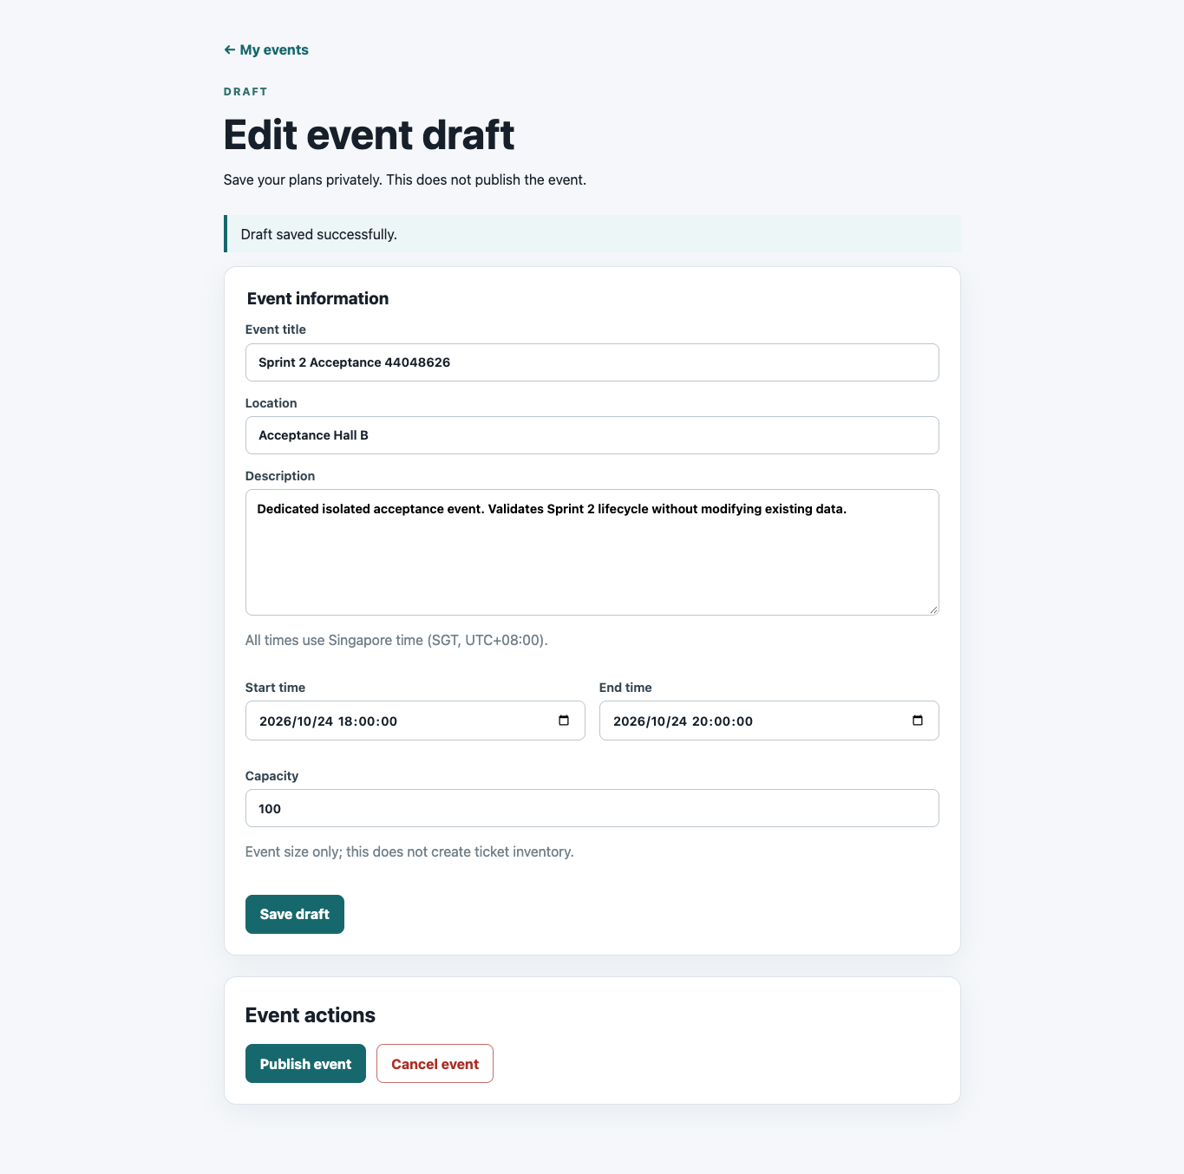
Figure 2. Saved draft and lifecycle actions. Capacity is event size, not ticket inventory.

User Interface continued
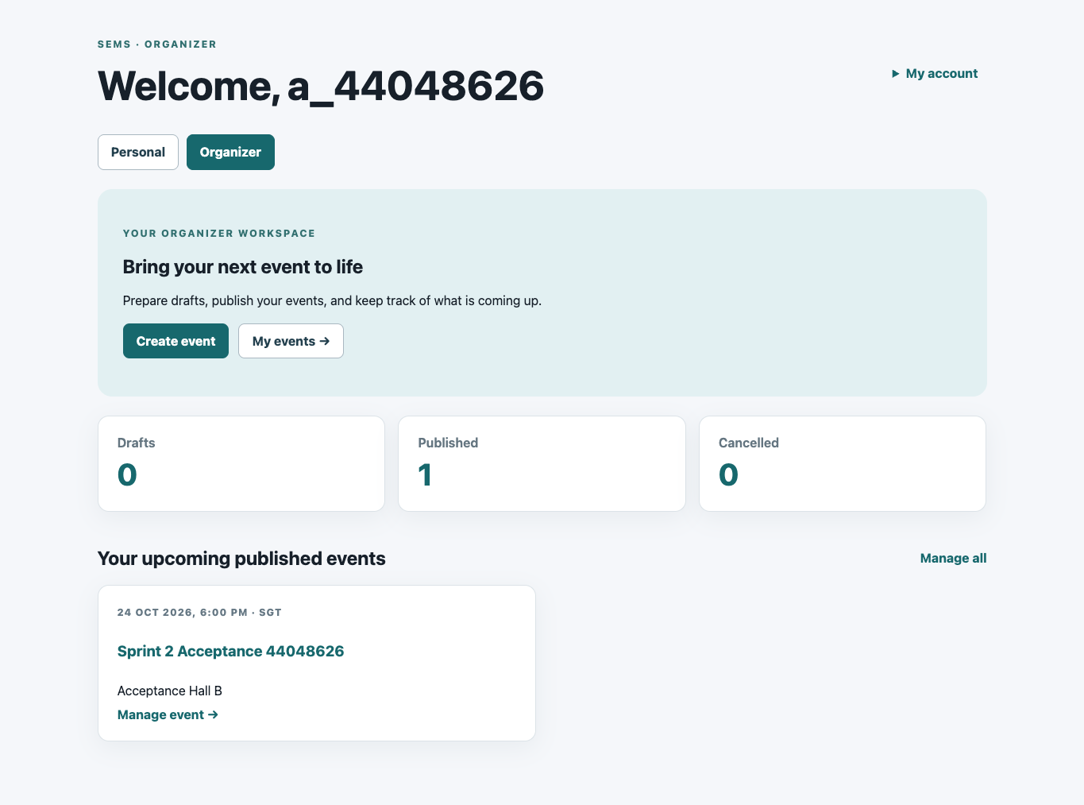
Figure 3. Organizer dashboard showing status counts and the upcoming published event.
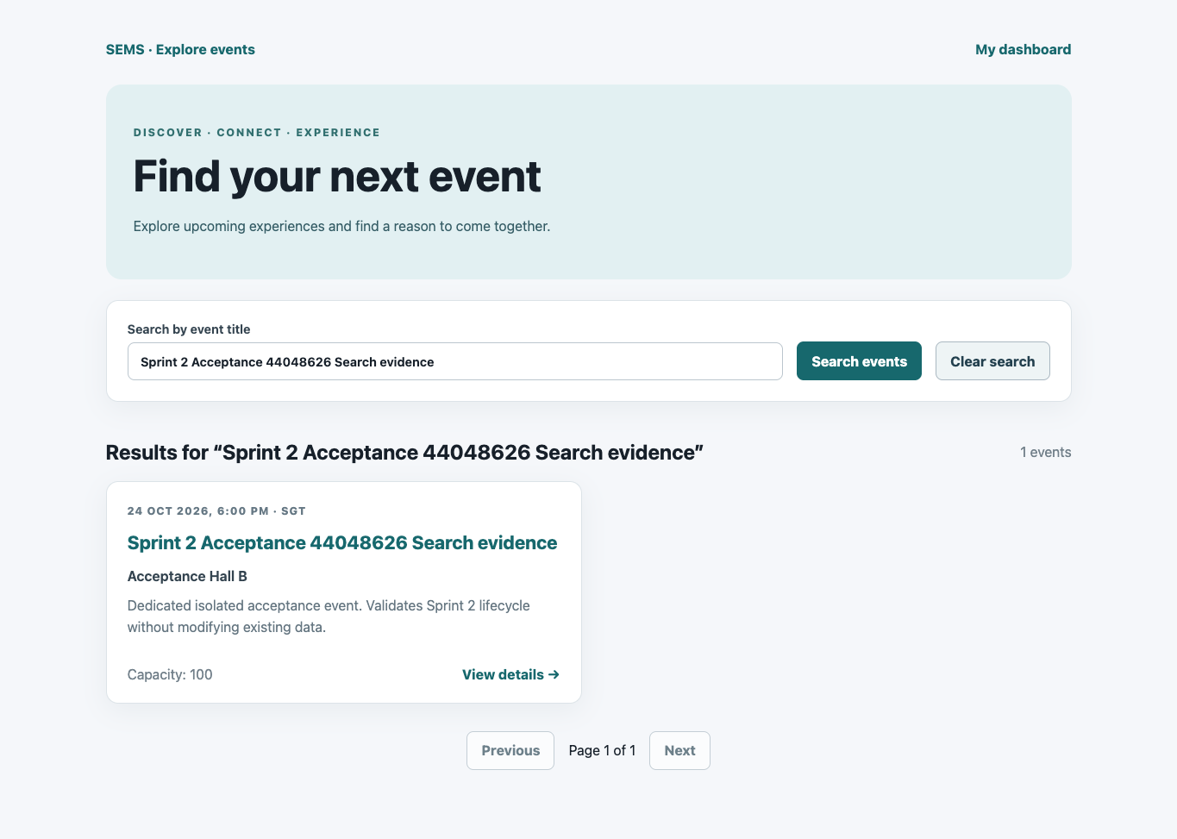
Figure 4. Published event returned by title search. This separate search-evidence event was cancelled after capture.
Other supplied acceptance evidence confirms owner isolation, removal after cancellation and 390px public/management layouts. The complete results are summarized in section 4.3; representative screenshots are selected here to keep the report concise.

Test evidence
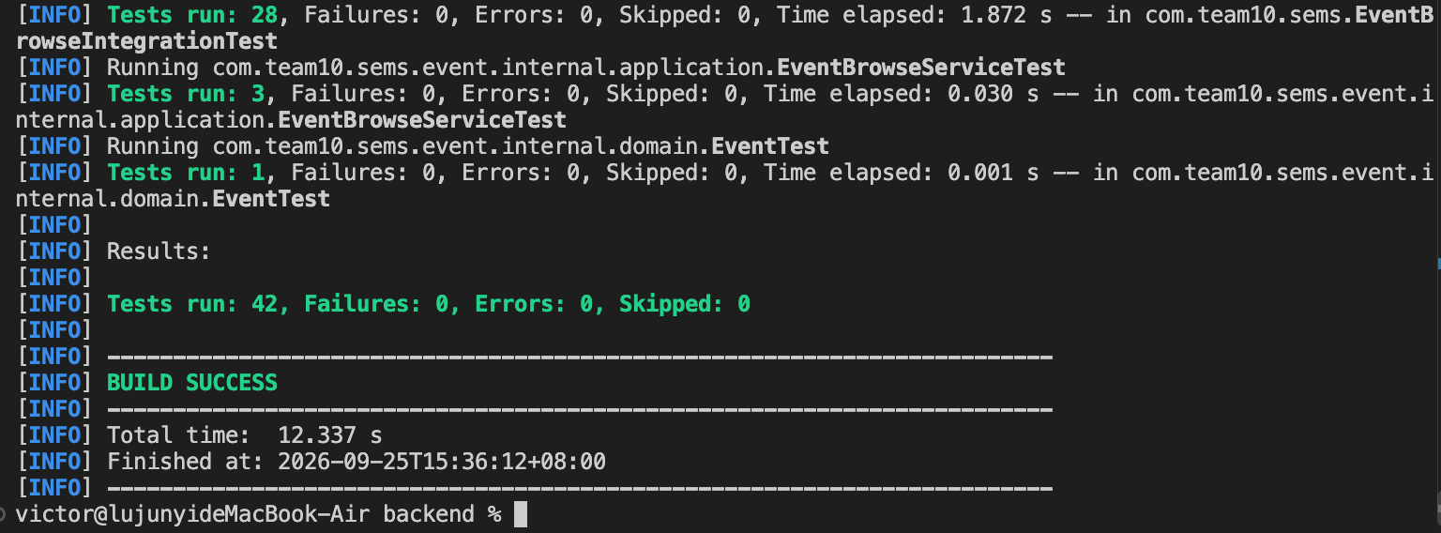
Figure 5. Backend result: 42 tests, zero failures, errors or skipped tests; BUILD SUCCESS. Completed 25 September 2026 at 15:36 SGT.
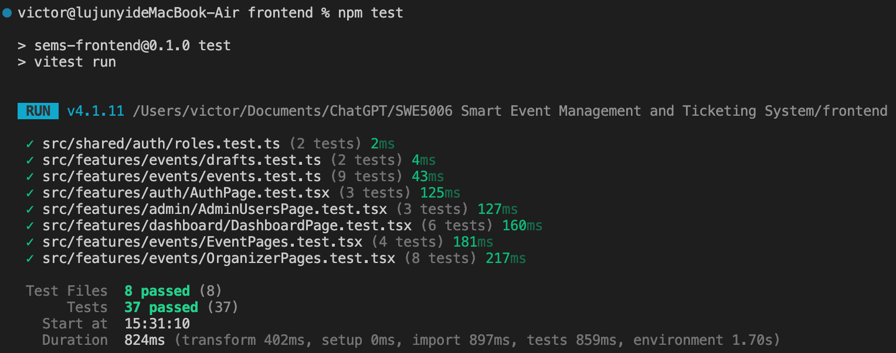
Figure 6. Frontend Vitest result: eight test files and 37 tests passed.
Evidence | Result and coverage
Backend screenshot | 42 passed; visible suites include 28 EventBrowseIntegrationTest cases, three service tests and one domain test.
Frontend screenshot | Roles 2; drafts 2; event helpers 9; authentication 3; admin 3; dashboard 6; public event pages 4; organizer pages 8. Total 37.
Docker and browser acceptance | 16 grouped checks passed across two phases; no uncaught page errors. Real PostgreSQL, restart persistence, access isolation and lifecycle checked.
These are supplied execution results. The 24 September browser acceptance used Chrome 153, desktop 1365 × 950 and mobile viewport 390 × 844. It did not cover physical phones, other browsers, multi-page browser pagination, concurrent load or a full security scan. The frontend screenshot is a component/helper test run, distinct from browser acceptance.

Continuous integration evidence
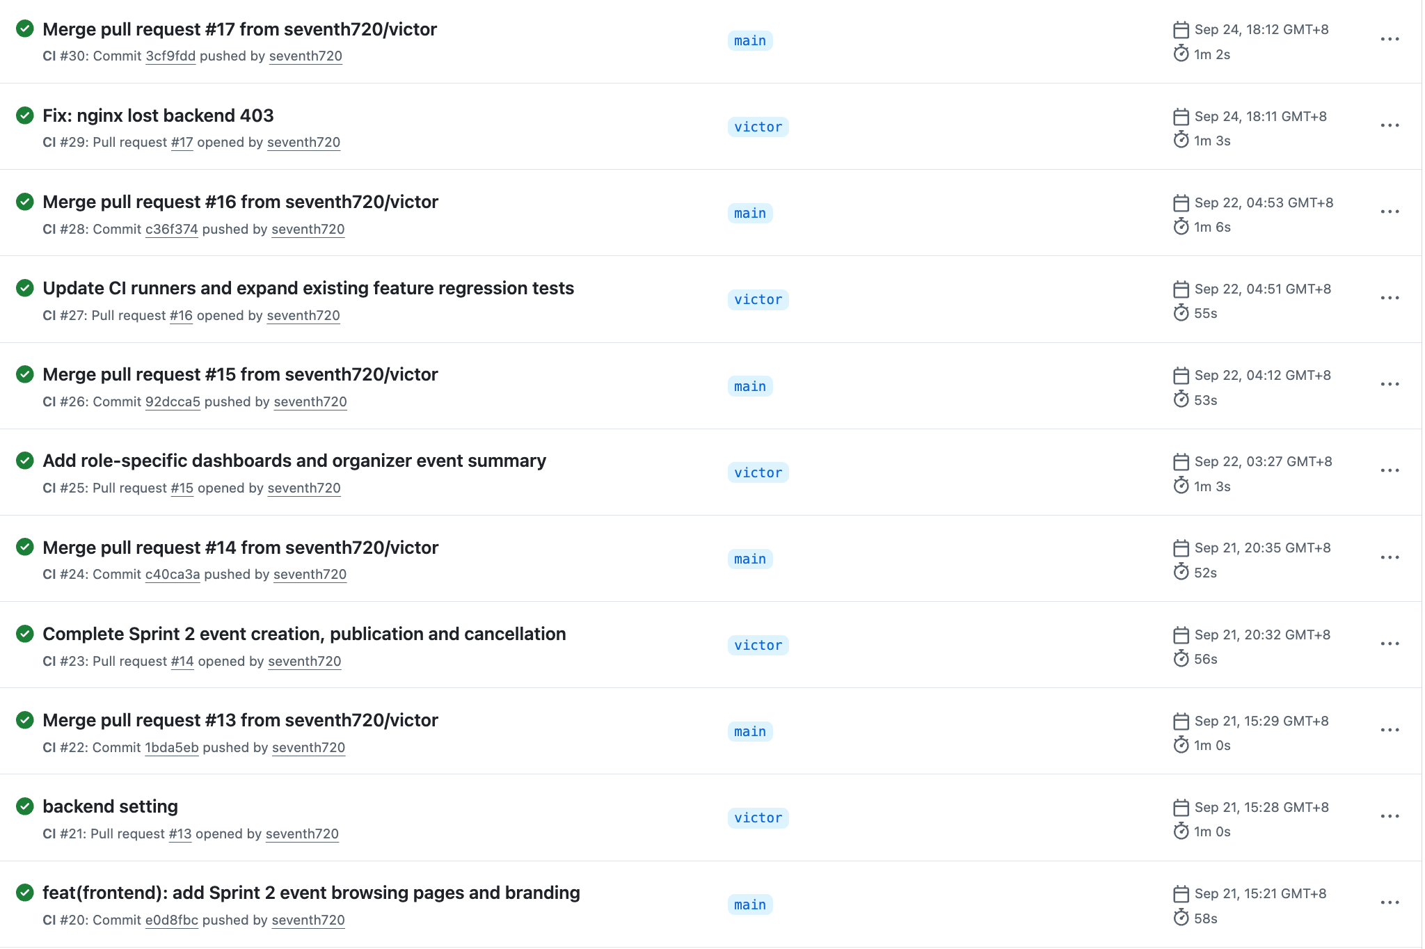
Figure 7. Eleven visible successful CI runs (#20–30), covering Sprint 2 development and PRs #13–17.
The latest visible run is CI #30 on main for merge commit 3cf9fdd, following PR #17. It passed on 24 September at 18:12 GMT+8 in 1 minute 2 seconds. CI #29 for the Nginx login-403 fix also passed. Earlier runs cover event lifecycle completion, role-specific dashboards and expanded regression tests.
The inspected workflow runs backend Maven verification and coverage, PostgreSQL integration tests, and frontend typechecking, tests and production build. The screenshot establishes successful workflow runs; it does not show individual job logs, a coverage percentage or another member’s approval.
The acceptance README recorded the Nginx fix as uncommitted at execution time. The later CI screenshot supplies the subsequent PR and merge evidence. Retain the acceptance records alongside PR #17 and CI #30 to trace the deployment issue through its fix and integration.
No dedicated SAST/SCA or staging-deployment job appears in the inspected workflow. Remaining process follow-up is to reconcile the workbook’s evidence checklist and record Review/Retro decisions and peer approval. Use-case/model items remain documented as carry-over rather than expanded into final-report design work.

